PRACTICAL WEEK 6

Task 1: Create a client-sewer application using Named Pipes (FIFOs). The client sends messages and the Server processes and responds to them. Analyze FIFO behavior when multiple clients communicate simultaneously.

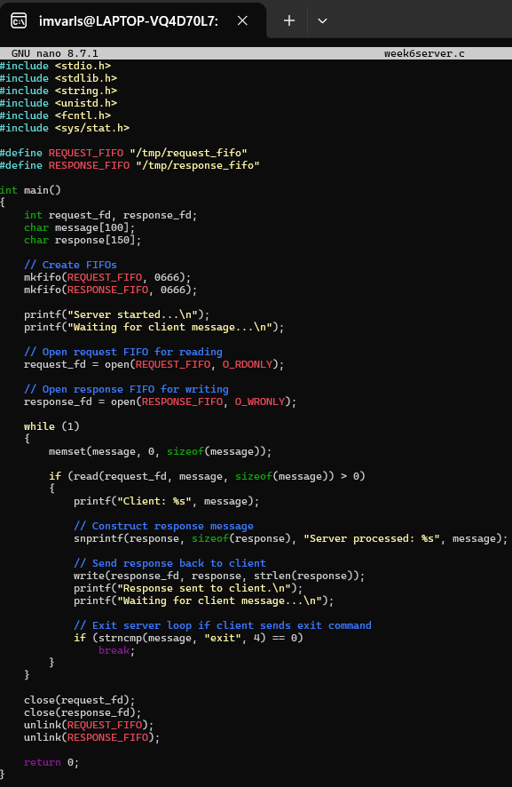

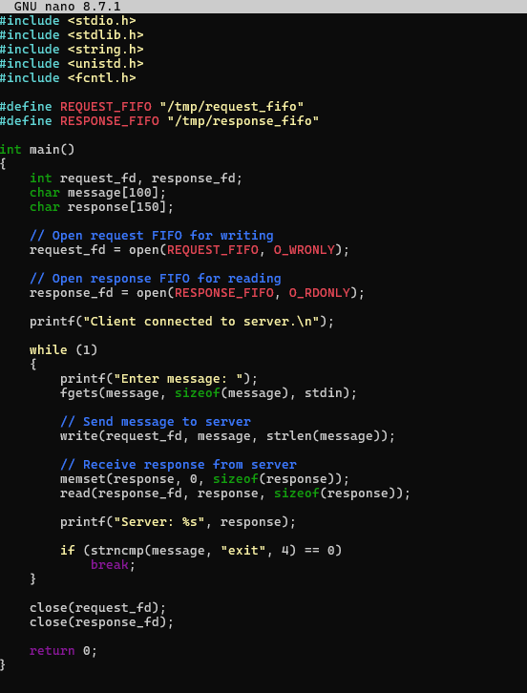

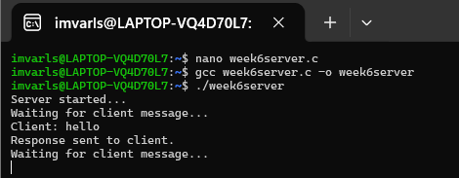

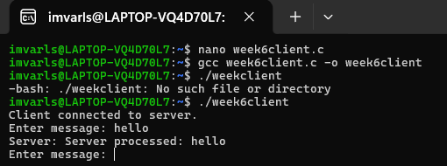

Observation
- Two Named Pipes (FIFOs) were created for communication between the client and server.
- The client successfully sent messages to the server through the request FIFO.
- The server read the messages, processed them, and sent the response back to the client through the response FIFO.
- Communication was bidirectional: Client → Server and Server → Client.
- The FIFO follows the First-In-First-Out (FIFO) principle, so messages are generally read in the order in which they are written.
- When multiple clients communicate with the same server, their requests are received through the common FIFO and are handled according to the order of their writes.
- FIFO communication provides synchronization between processes because a process may wait until another process opens/writes to the FIFO.
- After the client sends exit, the server sends a termination response and closes the FIFOs.

Task 2: Create a POSIX signal handling program that captures SIGINT, SIGTERM, and SIGUSRI. Demonstrate asynchronous event handling and explain the role of signal handlers.

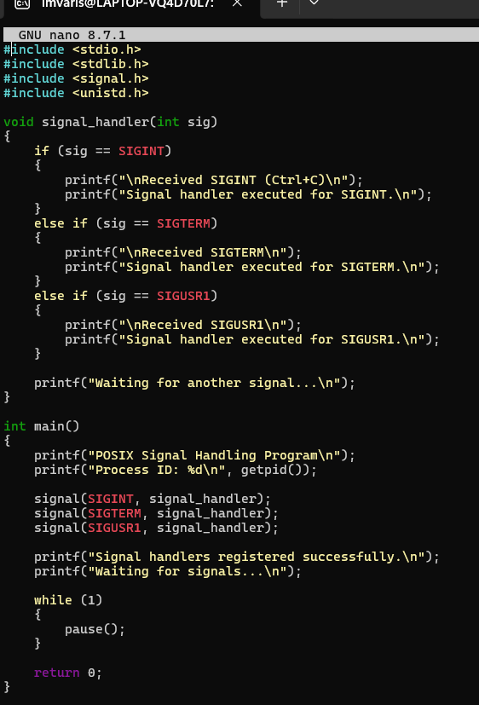

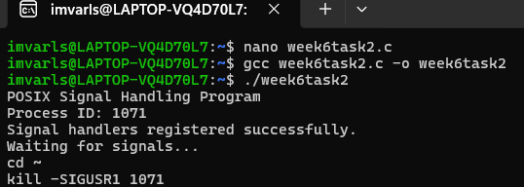

Observation
- A POSIX signal handling program was successfully implemented using the
signal() system call.
- Signal handlers were registered for SIGINT, SIGTERM, and SIGUSR1.
- SIGINT was generated using Ctrl+C and was successfully caught by the signal handler.
- SIGUSR1 and SIGTERM were sent to the process using the kill command.
- Whenever a signal was received, the corresponding signal handler was executed immediately.
- The program continued its execution after handling the signals instead of terminating.
- This demonstrates asynchronous event handling, because signals can interrupt a process at any time and cause the registered handler to execute.
- The signal handler is a function that specifies the action to be performed when a particular signal is received.
- The process ID (PID) is required to send signals to a specific running process using the kill command.

